**Part B**

**Q5**

1. D
2. D
3. D
4. D
5. C
6. C
7. C
8. C
9. A
10. A
11. A
12. A
13. B
14. B
15. B

**Q6**

**Diagram the LR(1) states for the given grammar , and construct the LR(1) parsing table. Indicate clearly any conflicts.**

**0. S → G $**

**1. G → P**

**2. G → PG**

**3. P → id : R**

**4. R →**

**5. R → id R**

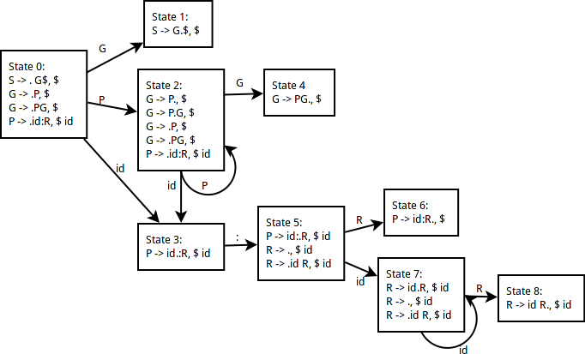

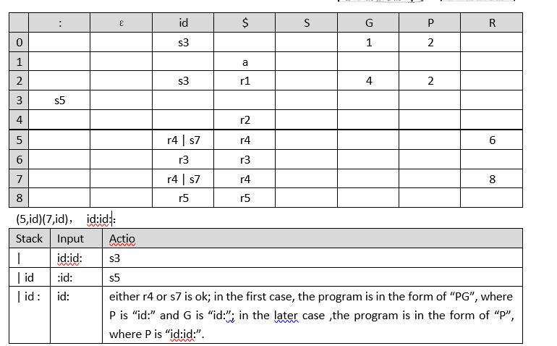

(c ) Not LR(1) DUE TO SHIFT REDUCE CONFLICTS AT STATE 5 AND 7.